Oracle Cloud Control 13c on Azure IaaS

For a full infrastructure support of Oracle VMs and products, Oracle Cloud Control is the defacto product to be used. Where a single database can be monitored with Oracle Cloud Control Express, an entire environment is best suited to the enterprise version installed in Azure and on it’s own Azure IaaS VMs.

**Cloud Control has the following components:**

* Oracle Management Repository, (OMR) comprised of an Oracle database.
* Oracle Management Service, (OMS) Service and Cloud Control portal/user interface
* Weblogic middle tier, this is a built in and proprietary weblogic deployment that is part of the installation.
* Management Agents to be deployed to targets to be monitored and managed.
* Miscellaneous connectors, plugins, software that can be stored for automation and BI Publisher for reporting.

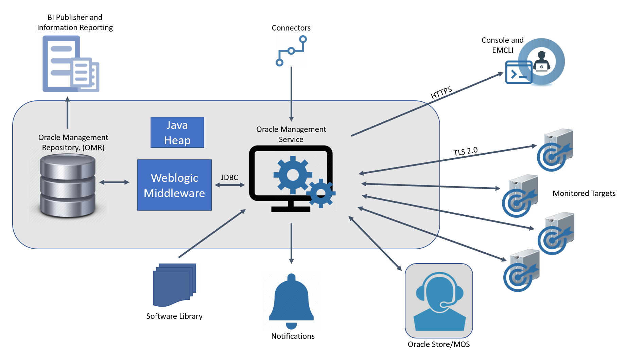

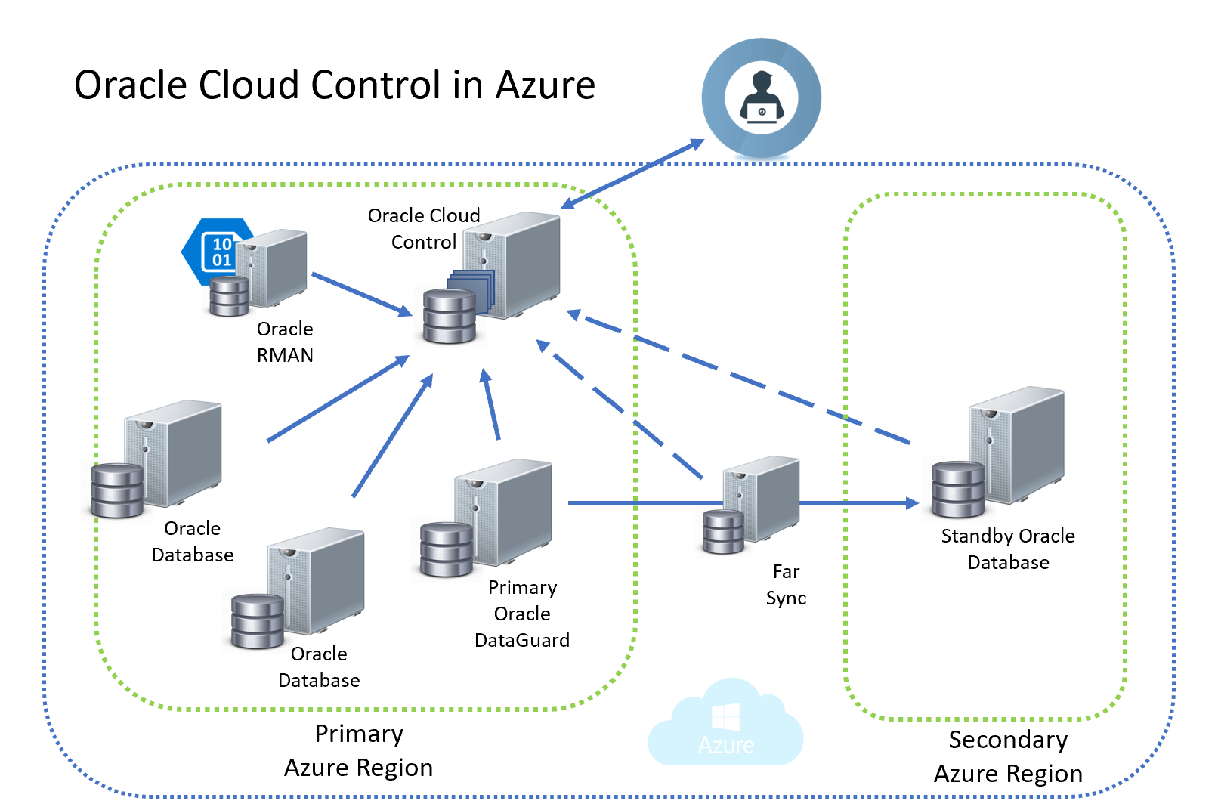

Understanding basic [Cloud Control concepts](https://docs.oracle.com/en/enterprise-manager/cloud-control/enterprise-manager-cloud-control/13.3.1/emadv/understanding-basics.html#GUID-2EB3506C-356A-430B-A85B-EACC793110FF) can help you with the steps going forward.

# Plan out Requirements

Cloud Control is the centralized repository for all Oracle monitoring, alerting, management and requires considerable resources to perform the required tasks, as well as manage the repository data. Sizing for a VM installation in the cloud is different than an on-prem installation. Configurations are adjusted for data retention, latency, etc. The sizing recommendations take this into consideration.

## VM Requirements

|  |  |  |  |
| --- | --- | --- | --- |
| Resource | Small | Medium | Large |
| Configuration | 1 OMS, <1000 Targets, <100 Agents, <10 Concurrent User Sessions | 2 OMSes, >=1000 but <10,000 Targets, >=100 but <1000 Agents,>=10 but <25 Concurrent User Sessions | 2 OMSes, >=10,000 Targets, >=1000 Agents, >=25 but <=50 Concurrent User Sessions |
| vCPU | 8 | 16 | 32 |
| Memory | 12G | 24G | 40G |
| JVM Heap Size | 1.7G | 4G | 8G |
| Storage | 18G | 24G | 36G |
| Hard Disk Space with ADP, JVMD | 21G | 29G | 41G |

Oracle Cloud Control, (AKA Oracle Enterprise Manager) is exceptionally network heavy as data collections occur from the target to the service and repository. It is crucial for the VMs to reside in the same geo-region as the targets and consider multiple deployments in each region for better performance.

# Licensing for Oracle Cloud Control

Before proceeding forward with the VM deployment, read through the [installation documentation for Cloud Control](https://docs.oracle.com/en/enterprise-manager/cloud-control/enterprise-manager-cloud-control/13.3.1/emadv/index.html) from Oracle.

# Deploy VM

## Ports

There are significant ports that will need to be available for the different services, agents and features used by Oracle Cloud Control.

To check whether a port is free, run the following command:

On Linux:

netstat -an | grep <port no>

* **Oracle Management Agent**

The default upload port for Management Agent is 3872. The same port is used for both HTTP and HTTPS. If 3872 is not available, then the first available free port from the range 1830 to 1849 is selected.

* **Administration Server**

The default HTTPS port for Admin Server is 7101. If 7101 is not available, then the first available free port from the range 7101 to 7200 is selected.

* **Node Manager**

The default HTTPS port is the first available free port from the range 7401 to 7500 is selected.

* **Managed Server**

The default HTTP port is the first available free port from the range 7201 to 7300 is selected.

The default HTTPS port is the first available free port from the range 7301 to 7400 is selected.

* **JVM Diagnostics Managed Server**

If SLB is not configured, then the aforementioned HTTP and HTTPS upload ports of Enterprise Manager Cloud Control are used. If SLB is configured, then the ports configured for JVM Diagnostics on the SLB are used. Alternatively, in addition to the SLB configuration, if the HTTP upload port is enabled for Enterprise Manager Cloud Control, then the HTTP upload port also can be used by the JVM Diagnostics Agents for communicating with the JVM Diagnostics Engine.

* **Oracle BI Publisher**

The default HTTP port for Oracle BI Publisher is 9701. If 9701 is not available, then the first available free port from the range 9701 to 9750 is selected.

The default HTTPS port for Oracle BI Publisher is 9801. If 9801 is not available, then the first available free port from the range 9801 to 9850 is selected.

* **Oracle HTTP Server**

The default HTTP port for Oracle HTTP Server is 9788. If 9788 is not available, then the first available free port from the range 9751 to 9800 is selected.

The default HTTPS port for Oracle HTTP Server is 9899. If 9899 is not available, then the first available free port from the range 9851 to 9900 is selected.

* **Java Object Cache (JOC)**

The default JOC port is 23456. If 23456 is not available, no alternate port is used, so ensure that port 23456 is free.

Follow the steps to download and install the Oracle database software, as this will be required to support the repository for the Oracle Cloud Control installation **<link to Oracle on IaaS doc>.** The OMR database will be installed as part of the Cloud Control installation and no database has to be pre-created for the next steps to be successful. Due to the unique features required for the OMR, recommendation is to let the installation to create and configure the database.

# Download Oracle Cloud Control Software

Software for Oracle Cloud Control can be downloaded from Oracle at the [following link](https://www.oracle.com/enterprise-manager/downloads/cloud-control-downloads.html). There are significant number of files and due to the size, recommendation is to download directly to the VM vs. downloading to a local workstation and uploading to the VM.

Perform the pre-installation [configuration of users and groups](https://docs.oracle.com/cd/E24628_01/install.121/e22624/preinstall_req_os_grps_usrs.htm#EMBSC140).

Oracle Cloud Control is a UI installation, please ensure that you’ve [configured either Cygwin](https://docs.oracle.com/cd/E24628_01/install.121/e22624/preinstall_req_cygwin_ssh.htm#EMBSC150) or another GUI emulator to access the host before attempting the next step.

# Perform Installation

Once the Azure VM is configured, there are only minor changes that need to be taken into consideration when performing an installation for Oracle Cloud Control.

1. Recommendations to keep the Oracle Management Service, (OMS) and the Oracle Management Repository, (OMR) on the same VM.
2. Make sure the proper ports are open for communication to and from Cloud Control and targets, (hosts and databases, etc. monitored by Cloud Control).
3. Download the software for database and Cloud Control
4. Ensure the users are configured with the correct privileges and rights to perform the actions required.

Follow the steps to perform an installation using the [following instructions](https://docs.oracle.com/cd/E24628_01/install.121/e22624/install_em_exist_db.htm#EMBSC159).

# Install Cloud Control Agent

Installing Cloud Control Agents is done by either a push, (from Oracle Cloud Control Portal) or pull, (the target pulls the installation from the Cloud Control) method. Instructions to install the Cloud Control Agent can be found [here](https://docs.oracle.com/cd/E24628_01/install.121/e22624/install_agent.htm#EMBSC181). There is an automation deployment where Cloud Control is able to scan an IP range and install agent software to any target it discovers and notify that it’s ready to be monitored.

# Create Management Templates

Management templates offer a way to ensure that databases meet SLAs for uptime and that each database is monitored, managed and alerted with consistent measures. Using templates saves time from manual set up when a new target is added to the repository. Templates can be created for hosts, databases and any other products that Oracle Cloud Control contains as a target.

Although template creation is missing from the official administration guide, one of Oracle’s closest partners and provider of OEM plugins has a guide that can assist in [setting up management templates](https://bluemedora.com/creating-and-applying-custom-monitoring-templates-in-oracle-enterprise-manager-13c/).

# Advanced Support

Knowing how to manage and troubleshoot issues with Cloud Control is important, especially in a cloud environment. The basic administration guide for Cloud Control 13c can be found [here](https://docs.oracle.com/cd/E24628_01/install.121/e22624/toc.htm).

Oracle Cloud Control requires patching and updating of both the software, the repository, as well as the target agents. There are ways to automate these tasks to ease the demands on internal resources. Please see the [Automated Patching documentation from Oracle for Agents](https://docs.oracle.com/cd/E29505_01/doc.1111/e24473/patching.htm).